Erin Mackey
Honest Writing for Young Christian Readers

www.ErinMackeyAuthor.com
Life
Christian. Wife. Author

As a Christian woman with a love for writing, it’s no surprise that Erin Mackey’s award-winning books have a way of resonating with her young readers.

Her works include children’s books, picture books and novels like Laurel Hill: New Beginnings, part of a series meant for 10 to 13 year olds that lightly tackles real issues faced by young Christian girls in today’s world.

Mackey was fortunate to grow up in a loving Christian home with her mother, father and younger sister in New Jersey, not far from the Jersey Shore, before moving to West Virginia as a teenager. Her diverse background in various fields, including nursing, corrections, system analysis and forensics, has given Mackey a unique perspective on life, a quality that’s reflected in her works.

Today, Mackey lives in Martinsburg, West Virginia, right outside of the Washington D.C., area with her husband. She enjoys spending time with her nieces and nephew, who have been a major influence on her writing.

Erin is a member of the New Atlantic Independent Booksellers Association (NAIBA) and the National Association of Professional Women (NAPW).

www.ErinMackeyAuthor.com
Laurel Hill: New Beginnings

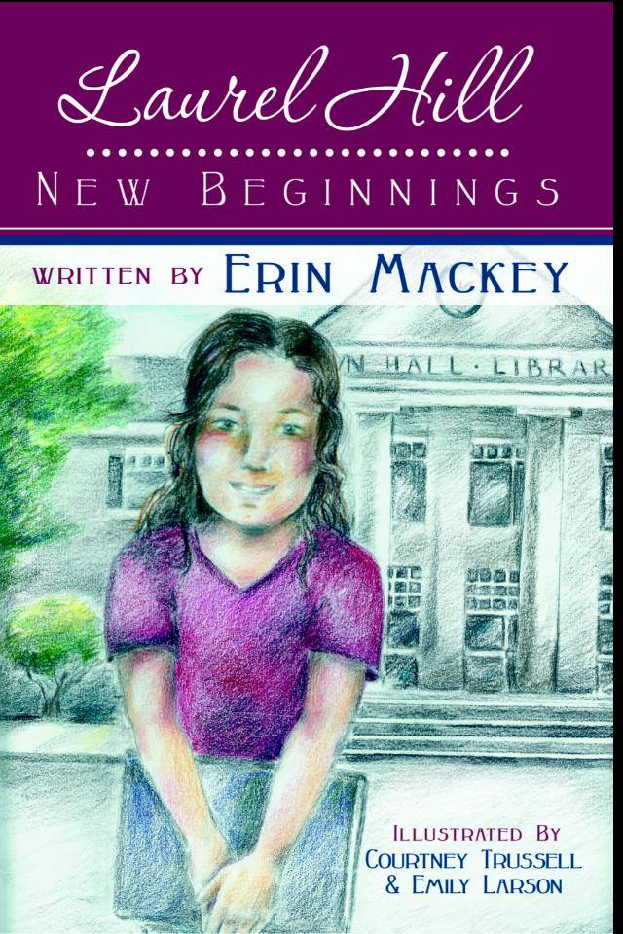
Laurel Hill: New Beginnings is the first in a series of novels meant for 10 to 13 year olds. The story follows six young Christian girls and their joys and struggles they face throughout childhood. It opens with five friends in a rural small town. The story then brings in a sixth young girl, who is new to the town, and shows the relationship that develops between her and the five friends.

Throughout the manuscript, there are several main events that transpire, including the girls solving of the mystery of stolen bicycles, celebrating the end of the school year at an amusement park and even attending a few birthday parties. There also are some obstacles and issues that are brought to light throughout the story as the girls learn to deal with their struggles. By relying on God for wisdom and guidance, whether dealing with a bully or overcoming the pain of losing a loved one, Mackey’s characters learn to display faith and love in their daily walks as young people.

Mackey says her six main characters represent today’s young Christian girls who are trying to keep Christ as their focus as they walk through life. Each of the girls has her own unique personality, talents and passions that any young girl will clearly identify with.

www.ErinMackeyAuthor.com
Sell Sheet
Laurel Hill: New Beginnings

Category: Christian/Children’s
Soft Cover Suggested Retail price: $8.99
eBook Suggested Retail Price: $3.99
Trim Size: 9” x 6” Trade Paperback
Page count: 82
Soft Cover ISBN: 978-1-4624-0779-1
eBook ISBN: 978-2-4624-0779-1
Available at: Amazon.com, BarnesandNoble.com, and InspiringVoices.com

Laurel Hill: New Beginnings tells an exciting story about finding new friends, solving mysteries, learning to deal with bullies and making memories that will last a lifetime. Maggie and her new friends discover that new beginnings show how God renews his promises to us day by day.

Laurel Hill: New Beginnings is the first book in Mackey’s Laurel Hill series, which is aimed at girls 8 to 12 years old. It is a Christian book series that was published by Inspiring Voices in October 2013.

www.ErinMackeyAuthor.com
Author Q & A

What inspired you to start writing?

What type of lessons do you teach through your books?

What kind of issues do you tackle in the Laurel Hill series?

Who inspired the characters in the Laurel Hill series?

Laurel Hill: New Beginnings was nominated as a National Indie Excellence Finalist. What did that mean to you?

www.ErinMackeyAuthor.com
Book Excerpt
From Laurel Hill: New Beginnings

Chapter 1: Birthday Surprises

“Happy birthday, Katie!” Amy yelled as she ran over to her group of friends. Although she was normally shy in public, Amy was bubbly and herself when she was around her best friends. The girls had become friends several years before when they went to a summer camp together as part of a church group. Ever since then, Amy, Jennifer, Morgan, Katie, and Nikki had become almost inseparable. Katie was the youngest in the group having turned ten today, and the rest of the girls were already eleven. Amy was the oldest, as she would be the first to turn twelve in August. Even though Katie was younger, she had been moved up two years in school and was in sixth grade with the rest of the girls because she was so smart. She had always gotten straight A’s, and she hardly ever had to study. Sometimes it bothered her older sister, Morgan, because Morgan had to study hard to keep her grades as good as they were. But Morgan was a good student too, so she never got mad or jealous of how easy school seemed for Katie.

“So are you excited about turning ten, Katie?” asked Amy’s mom, Mrs. Madison. She worked at Faith Bible Chapel, where the girls and their families went to church.

“I guess so. It’s kind of exciting since I’m almost a teenager now,” Katie answered.

“Well, enjoy each year as it comes, dear. Believe me, they go by fast enough!” said Mrs. Madison as she walked off to chat with some of the other parents at the party.

“So, Katie, what are you doing tomorrow for your birthday?” Nikki asked.

“Well, after church we’re gonna go play miniature golf at Sleepy Hollow. Then we’ll go out for pizza since it’s my favorite, and dad has some special movie planned at the theater just for us to watch! He won’t tell me what it is. He said it’s going to be a big surprise,” Katie said as she looked questioningly over at her older sister.

“I don’t know either, I swear!” Morgan squealed as she threw her hands up defensively.

Just then, Katie’s mom announced that it was time to cut the cake, and everyone went over to the picnic table. Mrs. Johnson had spent all day Friday making the food and cake for the party, and everything looked wonderful! The cake was decorated in pink icing with white daisies and green leaves, and it looked good enough that a professional baker could have made it. Mrs. Johnson loved to bake and cook, and since she was a homemaker, she had become very good at baking all sorts of goodies, which always sounded good to Katie and Morgan’s younger brother, Gabe. Being four years old, he loved to lick the spoon whenever his mom was done baking.

Everyone sang Happy Birthday to Katie, and Gabe made funny faces at his sister as she blew out her candles. Katie blew them all out with one deep breath, and everyone clapped as Mrs. Johnson removed the candles and sliced the cake.

As they ate their cake and ice cream, they chatted and laughed until it was time to open the presents. Katie started opening her gifts but saved the ones from her best friends for last, knowing they would be special. When she got to them, she opened Jennifer’s first. It was a dark blue backpack with her name in white on the front with a little daisy next to it.

“You can keep all of your writing stuff in this backpack, Katie, and use your other one just for school now,” Jennifer said. Katie’s passion had always been writing stories, and she was quite good at it. All the girls knew she planned to be a writer when she grew up.

“Thank you, Jennifer! I love it,” Katie exclaimed with a smile.

“Open mine next, Katie!” Amy shouted excitedly.

As she ripped the wrapping paper off of the small box and opened it, everyone could see the silver pen and pencil set with Katie’s name engraved along the sides in black.

“Oh, they’re beautiful, Amy. Thank you!” Katie said.

Next Katie reached for Nikki’s present. Inside, she found copies of the books Charlotte’s Web, Stuart Little, and The Trumpet and the Swan, which she had been wanting for some time. “You remembered, Nikki! Thank you so much!” she exclaimed as she reached over and hugged her friend.

“You’re welcome,” Nikki answered with a smile.

Finally, she opened her sister’s gift. “I think it’s a book,” Katie guessed, feeling the present through the paper. As she removed the wrapping, she sat staring at the book. It was a beautiful leather-bound copy of Katie’s favorite book, Anne of Green Gables, with gold lettering imprinted on the cover and spine.

“It’s beautiful,” Katie said, still fingering the cover gently as she looked up and saw Morgan smiling at her.

“I know it’s your favorite,” Morgan said as Katie got up to hug her big sister.

“Thank you so much, Morgan. I love it,” Katie whispered as everyone shouted “happy birthday” again.

Mrs. Johnson started to clean up, and Mr. Johnson took Gabe in for a well-deserved nap while the kids went off to play games and listen to music in the backyard. But as they chatted and laughed, every once in a while Morgan would look up to see Katie smiling at her again. Later that evening, after the party was over and everyone had gone home, Katie went into Morgan’s room and asked, “Where did you find that book? I’ve never seen one like it. It must’ve cost you way too much!”

But Morgan just answered, “I just happened to find it in a bookstore, and I thought of you,” not telling her sister she had saved her allowance for two months to be able to buy the book.

“Thanks, Morgan. I love it, and I’ll always treasure it,” Katie said.

And as Katie went down the hall to her bedroom, Morgan couldn’t help thinking it was worth not buying that new CD she had wanted to see how happy her present had made Katie. And she had to smile to herself.

The next night, the Johnson family enjoyed a very competitive round of miniature golf, which Morgan won. Gabe came in second only because he kept cheating by picking up his ball, walking it over to the hole, and dropping it in. But everyone had a good time.

Then, after enjoying pizza at Ray’s, they all settled into one of the theaters at the Movie House, which the Johnson family owned. The last showing of the movie of the week was still playing in the other theater, but the last showing of the movie in this theater had been cancelled so the special presentation for the Johnson family could be shown. As Mr. Johnson settled into his seat and the lights dimmed, Katie waited in anticipation as credits sprang onto the screen and music filled the theater. Everyone began to clap and shout, and Katie squealed as the title flashed up on the big screen: the surprise movie was Pollyanna, one of her favorites. Her dad had ordered the movie especially for this night, and it was a wonderful private showing the family all enjoyed.

After the movie, the Johnson family headed home. Katie crept into her bed and thought how this had been the best birthday ever. Nothing could top all the fun and surprises she had had this year. She eventually drifted off to sleep with a smile on her face and a prayer thanking God for how much He had blessed her.
Book Reviews

“This book is amazing & my girls LOVE it!!!! Highly recommend this wonderfully written chapter book for young girls. A beautiful picture is painted of a girl forming new friendships in a small town, as you turn each page! A delight to read.”
-- Jwilson1129, Amazon.com 5-Star Review, 2013.

“What a great book! It is nice to see a book for young girls that is relevant but also age appropriate.”
--Colleen, Amazon.com 5-Star Review, 2013.

“Wonderful book!!!! Lovely story of friendship!!! Would make a wonderful Christmas gift for young girls 8-12!!! Looking forward to Book 2!!!”
--Sue, Amazon.com 5-Star Review, 2013.

“I thoroughly enjoyed reading the Laurel Hill: New Beginnings book with my daughter. The story is so engaging and relatable. I’m certainly looking forward to the next installment in the series!”
--Vanessa McGuigan, Independent Education Manager, 2014.

“…a book my students have loved and told me even before I had the chance to ask them.”
--Rhonda DeStefano, School Librarian and teacher for 19+ years, 2014.

Learn More

Mackey is available for speaking engagements, interviews and appearances.

She welcomes the opportunity to speak to reading and writing groups in person, via telephone or Skype.

To learn more about Erin Mackey and her books, visit:
www.ErinMackeyAuthor.com
@ErinMackeyBooks
https://www.facebook.com/ErinMackeyAuthor
www.linkedin.com/in/erinmackey1

Contact Info:
Erin Mackey
ErinMackeyAuthor@yahoo.com

www.ErinMackeyAuthor.com

